Profile of the

Quad-Cities Metropolitan

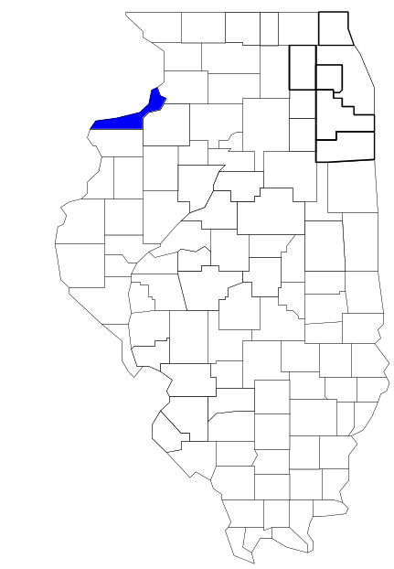Enforcement Group

Prepared by

The Research and Analysis Unit of the
Illinois Criminal Justice Information Authority

George H. Ryan, Governor
Peter B. Bensinger, Chairman
Candice M. Kane, Executive Director

March 2001



ILLINOIS
CRIMINAL JUSTICE
INFORMATION AUTHORITY

This project was supported by Grant # 99-DB-BX-0017, awarded to the Illinois Criminal Justice Information Authority by the Bureau of Justice Assistance, Office of Justice Programs, U.S. Department of Justice. The Assistant Attorney General, Office of Justice Programs, coordinates the activities of the following programs, offices and bureaus: Bureau of Justice Assistance, Bureau of Justice Statistics, National Institute of Justice, Office of Juvenile Justice and Delinquency Prevention, and the Office for Victims of Crime. Points of view or opinions contained within this document are those of the authors and do not necessarily represent the official position or policies of the U.S. Department of Justice.

Illinois Criminal Justice Information Authority
120 S. Riverside Plaza, Suite 1016
Chicago, Illinois 60606-3997
Telephone (312) 793-8550
Telefax (312) 793-8422
TDD: (312) 793-4170
World Wide Website http://www.icjia.state.il.us
ACKNOWLEDGMENTS

A number of organizations and individuals put a great deal of effort into the development of this document. The Authority’s Research and Analysis Unit is very grateful for the assistance provided by the following organizations:

Administrative Office of the Illinois Courts
Illinois Department of Human Services’ Office of Alcoholism and Substance Abuse
Illinois Department of Children and Family Services
Illinois Department of Corrections
Illinois State Police
Quad-Cities Metropolitan Enforcement Group
U.S. Bureau of the Census

In addition, the following individuals were instrumental in gathering, interpreting and presenting these data:

Sharyn Adams

Megan Alderden

Robert Bauer

John Condne

Karen Griffiths

Tracy Hahn

David Katz

Joseph Kozenczak

Gary Kupsak

Erica Morrow

David Olson

Adrianna Perez

Gerard Ramker

Robert Taylor

CONTENTS

Section Page Number

EXECUTIVE SUMMARY

I. Introduction 1
II. Trends in Violent Index Offenses and Arrests 3
III. Trends in Drug Arrests 6
IV. Trends in Drug Seizures 15
V. Trends in Prosecutions for Drug Offenses 17
VI. Trends in Percent of Convicted Drug Offenders Sentenced to Prison 19
VII. Trends in Drug Treatment Admissions in QCMEG Region, by Drug Type 24
VIII. Trends in Drug Exposed Births 27
IX. Summary of Drug Situation 28
X. Appendices 30
Map 1 1999 Percent of Illinois' County-level Population Covered by an
Authority-funded Multi-jurisdictional Enforcement Group or Task Force 31
Map 2 1999 Illinois Cannabis Seizure Rates, by County 32
Map 3 1999 Illinois Controlled Substances Seizure Rates, by County 33
Map 4 1999 Illinois Methamphetamine Seizure Rates, by County 34
XI. Bibliography 35

LIST OF FIGURES

Figure Page Number

Figure 1. Violent Index Offense Rates for Participating and Non-participating Agencies in Region Covered by QCMEG 3
Figure 2. 1999 Violent Index Offenses* Reported by Participating and Non-participating Agencies in Region Covered by QCMEG 4
Figure 3. Violent Index Arrest Rates for Participating and Non-participating Agencies in Region Covered by QCMEG 5
Figure 4. 1999 Violent Index Arrests* Reported by Participating and Non-participating Agencies in Region Covered by QCMEG 5
Figure 5. Total Drug Arrest Rates for QCMEG and Participating and Non-participating Agencies in Region Covered by QCMEG 7
Figure 6. 1999 Drug Arrests* Reported by Participating and Non-participating Agencies in Region Covered by QCMEG 8
Figure 7. Total 1999 Drug Arrests* Reported by Participating and Non-participating Agencies in Region Covered by QCMEG, by Drug Type 8
Figure 8. Drug Arrests by QCMEG 9
Figure 9. Percent of Total Drug Arrests Accounted for by QCMEG 10
Figure 10. Cannabis Arrests Rates in the Region Covered by QCMEG as Reported by Participating Agencies, Non-participating Agencies and QCMEG 11
Figure 11. Percent of Cannabis Arrests Accounted for by QCMEG
12
Figure 12. Controlled Substances Arrest Rates in the Region Covered by QCMEG as Reported by Participating Agencies, Non-participating Agencies and QCMEG 13
Figure 13. Percent of Controlled Substances Arrests Accounted for by QCMEG 14
Figure 14. QCMEG Drug Arrests for Possession versus Delivery, by Drug Type 14
Figure 15. Cannabis Seized and Submitted to ISP by Rock Island County and Seized by QCMEG 15
Figure 16. Powder and Crack Cocaine Seized and Submitted to ISP by Rock Island County and Seized by QCMEG 16
Figure 17. Number of Felony Filings in Rock Island County 17
Figure 18. Total QCMEG Drug Arrests and Percentage of Arrests Resulting in Prosecution 18
Figure 19. Sentences Imposed on Felons Convicted in Rock Island County
19
Figure 20. Sentences Imposed on Convicted QCMEG Drug Offenders 20
Figure 21. Number of Drug Offenders Committed to IDOC by QCMEG and Region Covered by QCMEG 21
Figure 22. Drug Offenders as a Percent of Total IDOC Commitments from Rock Island County 22
Figure 23. Drug Offenders Committed to IDOC from Rock Island County, by Offense Class 23
Figure 24. Substance Abuse Treatment Admissions from Rock Island County 24
Figure 25. Comparison of Drug Arrests by QCMEG and Participating and Non-participating Agencies vs. Drug Abuse Treatment Admissions in Rock Island County, 1999 26
Figure 26. Cases of Drug-Exposed Infants in Rock Island County 27
Figure 27. Availability of Drugs in Illinois, 1998 28
Figure 28. Price Per Gram in Illinois, 1998 29

EXECUTIVE SUMMARY

Since 1989, the Authority’s Research and Analysis Unit has received funds under the federal Anti-Drug Abuse Act of 1988 to document the extent and nature of drug and violent crime in Illinois and the criminal justice system’s response to these offenses. As a result of these efforts, the Authority has amassed a large amount of data measuring the extent and nature of drug and violent crime in Illinois and the impact these crimes have had on the criminal justice system. In addition, as part of its monitoring and evaluation efforts, the Authority also requires funded programs to submit monthly data reports describing their activities and accomplishments. This profile is intended to provide a general overview of the drug and violent crime problem in the jurisdictions covered by Illinois’ MEGs and task forces, and the response to these problems by the units.

Although the data presented in this report are by no means inclusive of all indicators, they do provide a general overview of drug and violent crime and the response and impact of the criminal justice system. The following represent general conclusions that can be made based on the data analyzed for this report.

- In 1999, four local Illinois police agencies participated in QCMEG (a participating agency is defined as one that contributes either personnel or financial resources to QCMEG). Officers assigned to QCMEG (totaling 13 in 1999, 4 from participating agencies) accounted for two percent of the total number of sworn police officers working for agencies participating in QCMEG.

- The violent Index offense rate was collectively higher across jurisdictions participating in QCMEG than among the combined jurisdictions that did not participate in QCMEG (page 3).

- The drug arrest rate was slightly higher in those jurisdictions participating in QCMEG than in those jurisdictions not participating for the majority of the years analyzed. The drug arrest rate achieved by QCMEG was much smaller than that achieved across both participating and non-participating agencies (page 6).

- When comparing the types of drug offenders arrested by those agencies participating in QCMEG, those agencies not participating, and QCMEG, it was found that QCMEG tended to target and arrest more serious drug law violators, specifically violators of the Controlled Substances Act, which tend to be felony-level offenses (page 9).

- The majority of all drug arrests reported by QCMEG, for either violations of the Cannabis Control Act or the Controlled Substances Act, involve drug sale or delivery (page 14).

- Between 1993 and 1999, the amount of cannabis and cocaine seized by QCMEG decreased (pages 15 and 16).

- Between 1991 and 1999, almost 86 percent of all drug arrests by QCMEG resulted in prosecution. Of these QCMEG drug offender prosecutions, 63 percent were for violations of Controlled Substances Act. In addition, between 1989 and 1999, 91 percent of all drug offenders who were prosecuted as a result of QCMEG activity were convicted (page 18).

- In 1999, among those QCMEG drug offenders convicted and sentenced, prison sentences accounted for the largest proportion (61 percent), followed by probation sentences (33 percent) and jail sentences (6 percent) (page 20).

- Between 1989 and 1999, prison sentences resulting from QCMEG cases accounted for 50 percent of all drug-law violators sent to prison from the region where QCMEG operates (page 21).

- Unlike the arrests made by the participating and non-participating agencies, the arrests made by QCMEG tended to involve the substances considered to be most serious (i.e., felony versus misdemeanor) and the substances for which a large proportion of community residents were seeking and receiving substance abuse treatment in 1999 (page 25).

I. Introduction

The Quad-Cities Metropolitan Enforcement Group (QCMEG) covers the Illinois county Rock Island. Rock Island had a 1999 total population of 147,675 – a one percent decrease from 1990. In 1999, four local Illinois police agencies participated in QCMEG. These include the Rock Island County Sheriff’s Office and the following municipal police departments: Rock Island, East Moline and Moline. These agencies served 83 percent of the population in the region covered by QCMEG in 1999 (see Map 1 on page 31). A participating agency is defined as one that contributes either personnel or financial resources to QCMEG.

In addition to agencies that participate in QCMEG, these Illinois counties are served by nine additional police departments that do not participate in QCMEG. According to the Illinois State Police, county sheriffs and local police departments, in the region covered by QCMEG, combined, employed 313 full-time police officers as of Oct. 31, 1999, 261 of which work in agencies participating in QCMEG. In comparison, there were a total of just 13 officers assigned to QCMEG in 1999, 4 of which were assigned by participating agencies, two from the Illinois State Police (ISP), six from Iowa law enforcement agencies and one from the Illinois Appellate Prosecutor's Office. Thus, the officers assigned to QCMEG during 1999 accounted for a relatively small proportion—two percent—of the total number of sworn police officers working in the participating police departments.

Since 1989, the Authority’s Research and Analysis Unit has received funds under the federal Anti-Drug Abuse Act of 1988 to document the extent and nature of drug and violent crime in Illinois and the criminal justice system’s response to these offenses. As a result of these efforts, the Authority has amassed a large amount of data measuring the extent and nature of drug and violent crime in Illinois and the impact these crimes have had on the criminal justice system. In addition, as part of its monitoring and evaluation efforts, the Authority also requires funded programs to submit monthly data reports describing their activities and accomplishments. To put this information into the hands of Metropolitan Enforcement Group (MEG) and drug task force directors and policy board members, the Authority’s Research and Analysis Unit has developed profiles – of which this is one – for each MEG and task force. The profile is intended to provide a general overview of the drug and violent crime problem in the jurisdictions covered by Illinois’ MEGs and task forces, and the response to these problems by the units.

In addition to administering federal block-grant funds that come to Illinois for crime control initiatives, the Illinois Criminal Justice Information Authority is also responsible for providing policymakers, criminal justice professionals and others with information, tools and technology needed to make effective decisions that improve the quality of criminal justice in Illinois. The Authority provides an objective system-wide forum for identifying critical problems in criminal justice, developing coordinated and cost-effective strategies, and implementing and evaluating solutions to those problems. The specific powers and duties of the Authority are delineated in the Illinois Criminal Justice Information Act (Illinois Compiled Statutes, Ch. 20, Sec. 3930). Two of the Authority’s many responsibilities are serving as a clearinghouse of information and research on criminal justice and undertaking research studies to improve the administration of criminal justice.

While the data presented in this report are by no means inclusive of all indicators, they do provide a general overview of drug and violent crime and the response and impact of the criminal justice system. In addition, these data are readily available and consistently defined through existing statewide data collection mechanisms. Some data presented in this profile have been analyzed differently than in previous years; therefore, caution must be taken when comparing numbers presented with previous profiles.
While a considerable amount of the information presented in this profile has been provided to the Authority by QCMEG, a number of state agencies have also provided data to the Authority that are included in this report. Specifically, the Illinois State Police, the Administrative Office of the Illinois Courts, the Illinois Department of Human Services’ Office of Alcoholism and Substance Abuse, the Illinois Department of Corrections and the Illinois Department of Children and Family Services all provided data used to develop this profile. The support and cooperation of these agencies and their staffs have helped make this report an informative and timely source of information on the activities of the criminal justice system in Illinois.

- Trends in Violent Index Offenses and Arrests

While most of Illinois’ Metropolitan Enforcement Groups and drug task forces are primarily involved in drug enforcement activities, it is clear that the relationship between drugs and violence is particularly evident in a number of Illinois communities. In addition, a number of MEGs and task forces have increased their involvement in the investigation of violent crime, particularly that associated with gang activity and violence related to drug distribution, sale and turf battles. One of the most commonly used indicators of the level of crime in a particular jurisdiction is the number of Index offenses reported to the police. In Illinois, as part of the Illinois Uniform Crime Reporting (I-UCR) program, every law enforcement agency in the state is required to report crime data monthly to the Illinois State Police (ISP). There are eight separate offenses that constitute the Crime Index, including murder, criminal sexual assault, robbery, aggravated assault (violent Index offenses), burglary, theft, motor vehicle theft and arson (property Index offenses). Although these eight offenses do not account for all crimes reported to the police, they are considered to be the most serious, frequent, pervasive and consistently defined by different law enforcement agencies.

In 1999, the number of violent Index offenses reported to the police in the region covered by QCMEG totaled 776, a 16 percent decrease from the 920 offenses reported in 1993. The majority (69 percent) of violent Index offenses reported to the police between 1993 and 1999 were aggravated assaults, while 19 percent were robberies.

During the period analyzed, the violent Index offense rate for the region covered by QCMEG decreased 14 percent, from 613 offenses per 100,000 population in 1993 to 525 offenses per 100,000 population in 1999. Similarly, the violent Index offense rate in the participating agencies decreased 10 percent, from 640 to 578 offenses per 100,000 population, while the rate in the non-participating agencies decreased 42 percent, from 469 to 273 offenses per 100,000 population (Figure 1). Thus, the violent Index Offense rate across jurisdictions participating in QCMEG was collectively greater than the violent Index Offense rate for jurisdictions not participating in QCMEG.
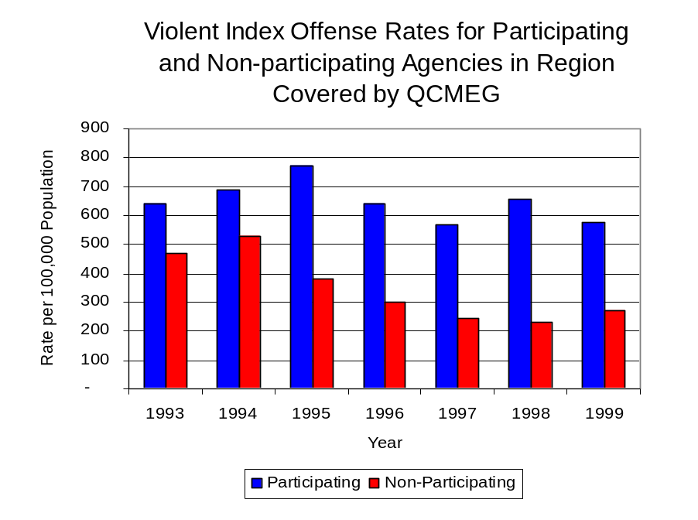
Source: ICJIA calculations using Illinois State Police and U.S. Census Bureau data
Figure 1

Across the 13 individual local law enforcement agencies covered by QCMEG’s jurisdiction, three agencies, the Rock Island Police Department, the Moline Police Department and the East Moline Police Department, accounted for 89 percent of all violent offenses reported to the police (Figure 2). Six agencies had fewer than ten violent offenses reported in 1999 and are excluded from Figure 2. When controlling for differences in the populations served by these law enforcement agencies, the violent Index offense rate ranged from 985 violent Index offenses per 100,000 population in Rock Island to 900 offenses per 100,000 population in Port Byron.
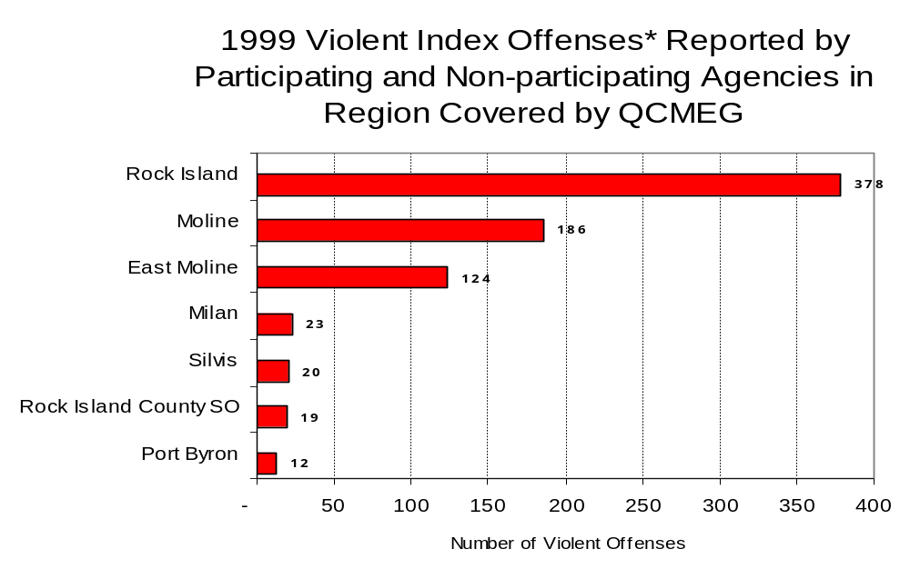
Source: Illinois State Police *Agencies reporting ten or more violent offenses
Figure 2

An indicator of the workload that law enforcement agencies place on other components of the justice system is the number of arrests made by police, including those for violent and property Index offenses and drug offenses. Unlike offenses, which are what police must respond to, arrests represent those offenders who may eventually be processed through other components of the justice system, including the courts, county jails, and state and local correctional programs.

Between 1993 and 1999, the number of arrests for violent Index offenses made by law enforcement agencies in the region covered by QCMEG decreased 11 percent, from 421 to 374. As with reported violent Index offenses, the majority (78 percent) of violent Index arrests were for aggravated assaults, followed by robberies (12 percent).

During the period analyzed, the violent Index arrest rate for the region covered by QCMEG decreased 10 percent, from 281 offenses per 100,000 population in 1993 to 253 arrests per 100,000 population in 1999. Similarly, the violent Index arrest rate in the participating agencies decreased nine percent, from 305 to 276 offenses per 100,000 population, while the rate in the non-participating agencies decreased six percent, from 152 to 143 offenses per 100,000 population (Figure 3).

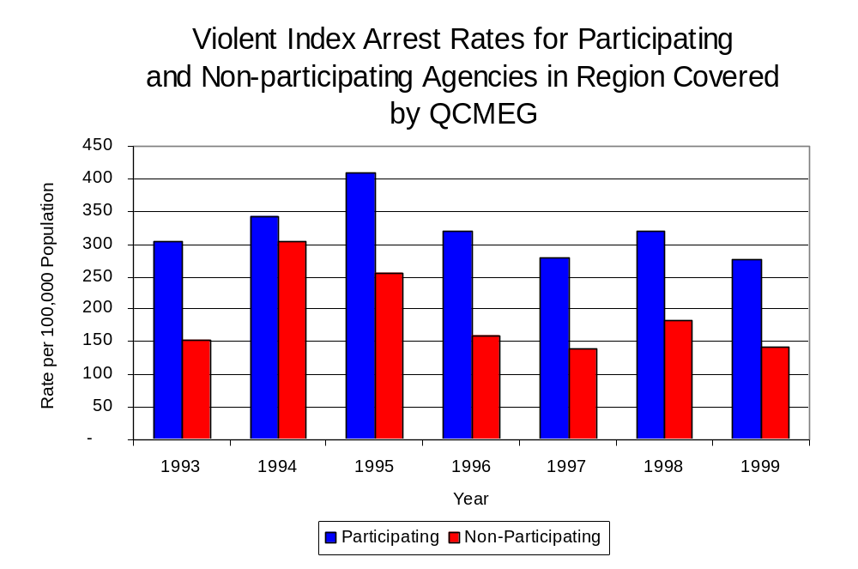
Figure 3
Source: ICJIA calculations using
Illinois State Police and U. S. Census Bureau data

The majority (76 percent) of arrests for violent Index offenses occurring in the region covered by QCMEG were made by two agencies. Eight agencies had fewer than ten arrests for violent Index offenses reported in 1999 and are excluded from Figure 4. Of the 374 violent Index arrests made in 1999, the Rock Island Police Department accounted for almost one-half (48 percent), followed by the Moline Police Department (28 percent).
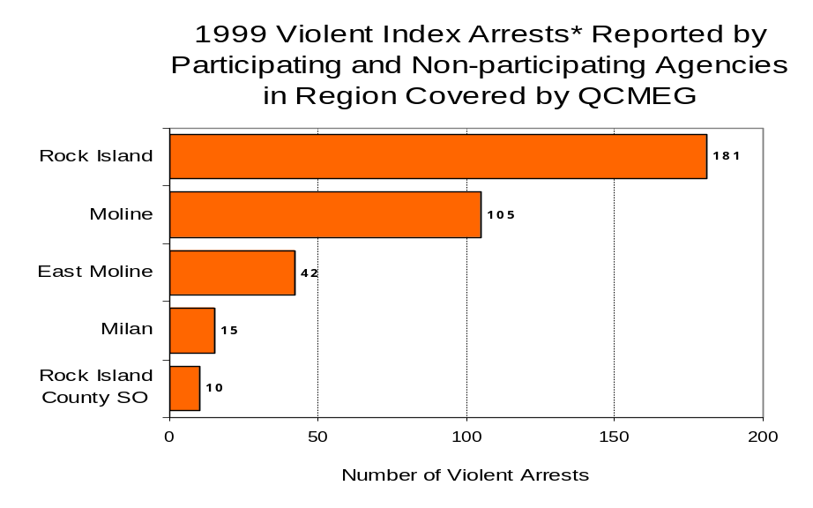
Figure 4
Source: Illinois State Police *Agencies reporting ten or more violent offenses
III. Trends in Drug Arrests

There are two sources of drug arrest data presented in this section. One source is the Illinois Uniform Crime Reporting (I-UCR) program that includes information submitted by local law enforcement agencies on the number of persons arrested for violations of Illinois’ Cannabis Control Act, Controlled Substances Act, Hypodermic Syringes and Needles Act, and Drug Paraphernalia Control Act. In addition, data on drug arrests made by Illinois’ MEGs and task forces are reported to the Illinois Criminal Justice Information Authority. In some jurisdictions, arrests made by the MEG or task force may be reported by both local law enforcement agencies through the I-UCR and to the Authority by the unit. In other jurisdictions, arrests made by the MEG or task force are only reported to the Authority by the unit. Therefore, in some instances drug arrests may be double counted – included in both local agency statistics reported to I-UCR and those of the MEG or task force. Currently there is no mechanism in place to ensure that drug arrest statistics are not being duplicated at both the local agency and MEG/task force level. This should be kept in mind when interpreting the information presented in the following section.

The majority of drug offenses in Illinois are violations of either the Cannabis Control Act – which prohibits the possession, sale and cultivation of marijuana – or the Controlled Substances Act – which prohibits the possession, sale, distribution or manufacture of all other illegal drugs, such as cocaine and opiates. Illinois also has various other laws prohibiting other drug-related activity. These include the Hypodermic Syringes and Needles Act – which prohibits the possession or sale of hypodermic instruments – and the Drug Paraphernalia Control Act – which prohibits the possession, sale or delivery of drug paraphernalia. In general, violations of Illinois Controlled Substances Act are considered to be more serious, since they primarily involve cocaine, heroin, methamphetamine, and hallucinogens, and are almost all classified under Illinois law as felonies. The majority of cannabis and drug paraphernalia offenses encountered by police, on the other hand, tend to be misdemeanor-level offenses.

In 1999, local law enforcement agencies in the counties covered by QCMEG reported 1,025 arrests for drug law violations, a 71 percent increase from 1993 (600 arrests). Between 1993 and 1999, arrests for violations of Illinois’ Cannabis Control Act out-numbered arrests for violations of the Controlled Substances Act every year in Rock Island County. During the same period, the number of arrests for violations of the Cannabis Control Act in this county increased 47 percent, from 318 to 469. Arrests for violations of the Controlled Substances Act increased 14 percent, from 181 to 207. In addition, arrests for violations of the Drug Paraphernalia Control Act, enacted in 1993, increased dramatically, from 97 in 1993 to 962 in 1999. Much of this increase can be attributed to a 1994 addition to the Drug Paraphernalia Control Act, which included the possession of drug paraphernalia as a violation.

Because arrests for violations of the Drug Paraphernalia Control Act are frequently made in conjunction with other drug offense arrests, these arrests may be double-counted, thus skewing the actual number of drug arrests. Therefore, only arrests for violations of the Cannabis Control Act and Controlled Substances Act will be used for drug arrest comparisons between QCMEG and the participating and non-participating agencies.

During the period analyzed, the drug arrest rate for violations of the Cannabis Control and the Controlled Substances Acts combined, in the region covered by QCMEG increased 38 percent, from 333 arrests per 100,000 population in 1993 to 458 arrests per 100,000 population in 1999. Similarly, the drug arrest rate in the participating agencies increased 60 percent, from 313 to 502, while the drug arrest rate for non-participating agencies decreased 44 percent from 435 to 245 arrests per 100,000 population. The arrest rate for QCMEG increased 97 percent, from 92 to 181 arrests per 100,000 population (Figure 5). Thus, while the drug arrest rate for non-participating agencies exceeded the drug arrest rate across jurisdictions participating in QCMEG in 1993 and 1994, beginning in 1995, the drug arrest rate in participating agencies was greater than the non-participating agencies in every year analyzed after 1994. Also, the drug arrest rate achieved by QCMEG was much smaller than that achieved across both participating and non-participating agencies.

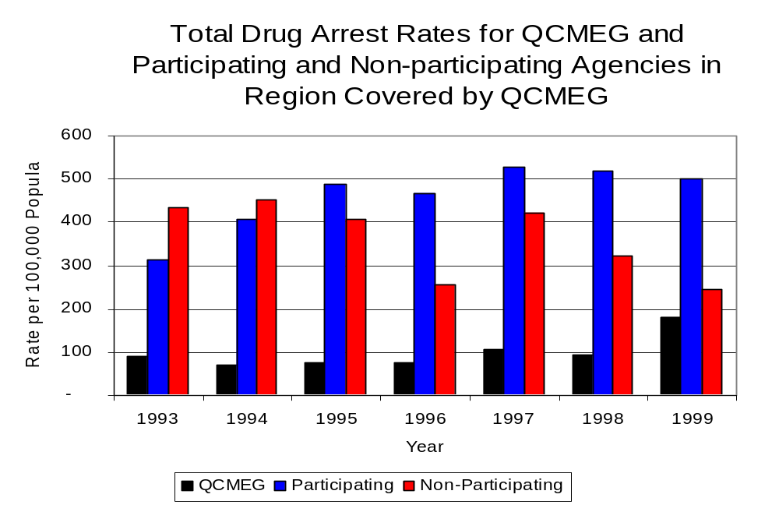
Source: ICJIA calculations using Illinois State Police, QCMEG and U.S. Census Bureau data
Figure 5

Across the local law enforcement agencies in the region covered by QCMEG, the total number of drug arrests, including the Cannabis Control Act, the Controlled Substances Act, the Drug Paraphernalia Act, and the Hypodermic Syringes and Needles Act, from zero to 453. Of the 1,025 drug arrests made during 1999 in the region, two agencies accounted for 68 percent of these drug arrests. Three agencies had fewer than ten drug arrests reported in 1999 and are excluded from Figure 6. Rock Island accounted 44 percent, while the Moline Police Department accounted for 24 percent, of all drug arrests in Rock Island County (Figure 6). Among those agencies listed in Figure 6, the top four agencies reporting the highest number of drug arrests participate in QCMEG.

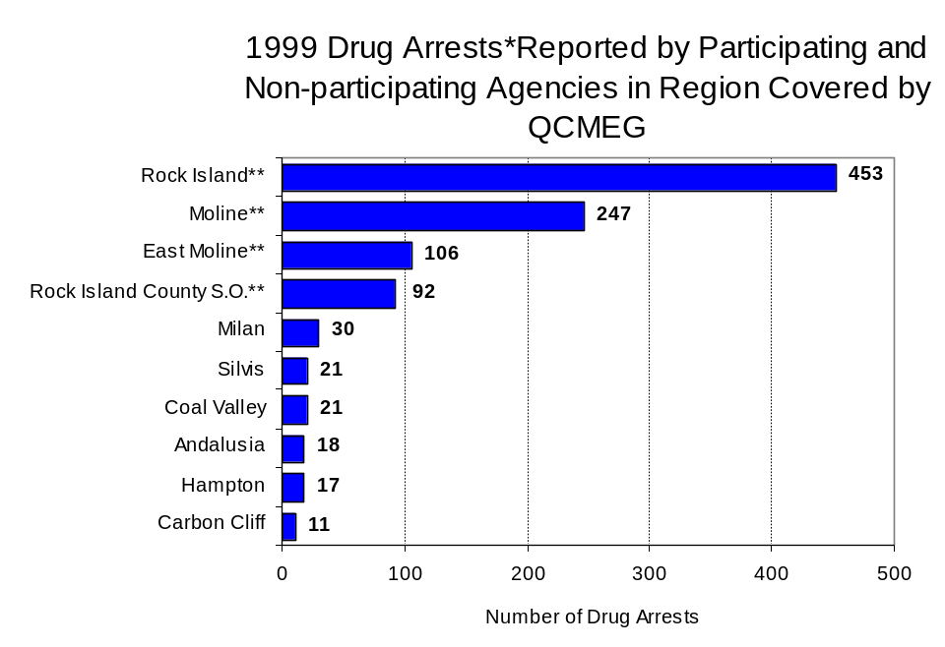
In addition to the dramatic difference in the number of drug arrests made, there are also
Figure 6
Source: Illinois State Police *Agencies reporting ten or more drug arrests
**Agencies participating in QCMEG
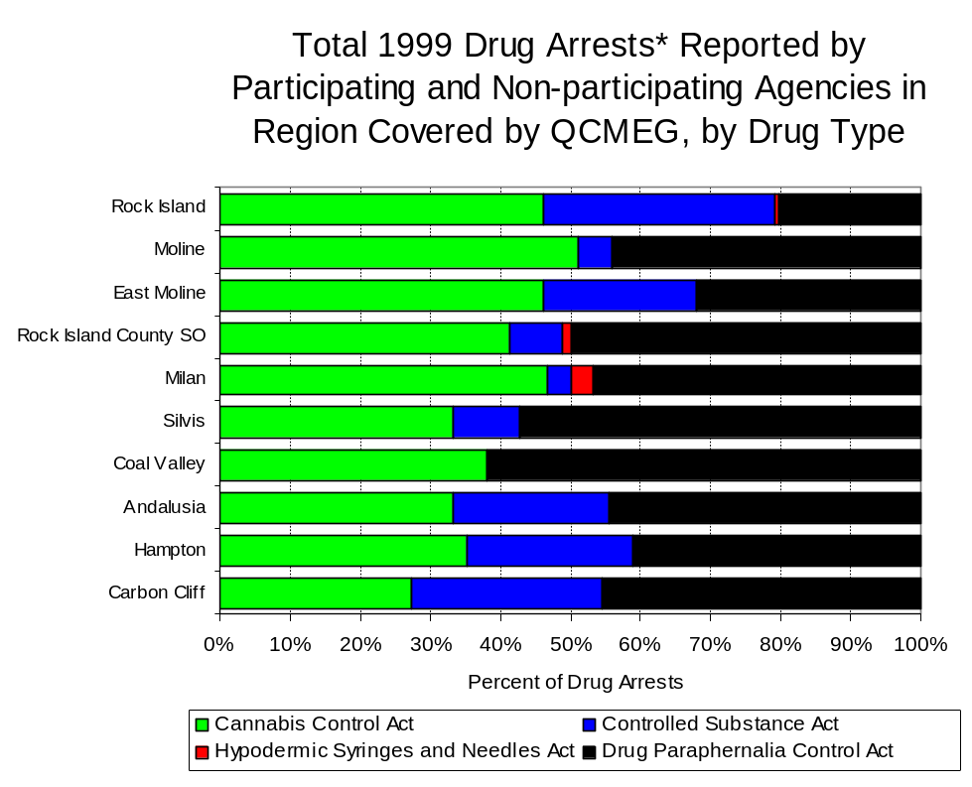
differences in the types of drug law violation arrests across the agencies in the region. In 1999, violations of the Cannabis Control Act accounted for the majority of arrests across most individual agencies in the region covered by QCMEG (Figure 7).
Figure 7
Source: Illinois State Police *Agencies reporting ten or more drug arrests

Between 1993 and 1999, the number of combined cannabis and controlled substances arrests made by QCMEG increased 91 percent, from 116 to 221 (Figure 8). Unlike drug arrests made by most local police departments in the region, violations of the Controlled Substances Act accounted for the majority of drug arrests made by QCMEG throughout most of the period analyzed. During the period analyzed, the number of QCMEG arrests for violations of the Cannabis Control Act increased 15 percent, from 66 to 76, while arrests for violations of the Controlled Substances Act tripled, from 49 to 145 (Figure 8).

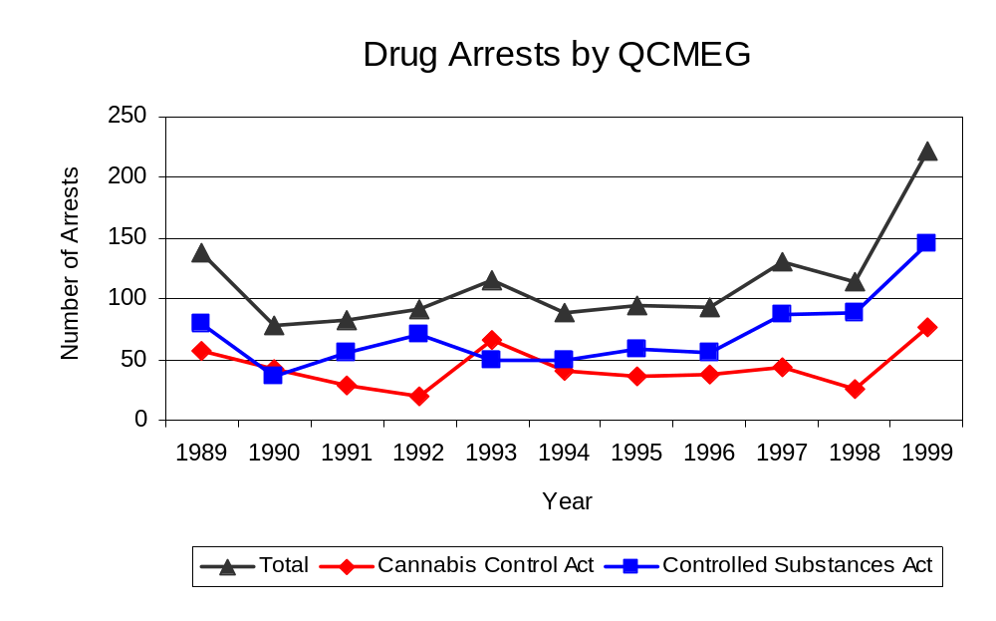
Between 1993 and 1999, the proportion of drug arrests accounted for by controlled substance violations increased for both participating and non-participating agencies in Rock Island County. For QCMEG, the proportion of drug arrests accounted for by controlled substance violations increased 52 percent between 1993 and 1999. In 1999, 66 percent of the drug arrests made by QCMEG were for violations of the Controlled Substances Act, compared to 43 percent in 1993. In 1999, arrests for controlled substances violations accounted for 42 percent of the drug arrests made in the participating agencies and 16 percent for the non-participating agencies, compared to 31 percent and 24 percent, respectively, in 1993. Thus, arrests by QCMEG were more likely than arrests by wither participating or non-participating agencies to involve violations of Illinois’ Controlled Substances Act, as opposed to the Cannabis Control Act. One interpretation of this pattern is that QCMEG is more focused in who they are targeting and arresting than local departments, and are also getting a more serious drug law violator, since violations of the Controlled Substances Act are more likely to involve felony-level offenses.
Source: QCMEG
Figure 8

The data presented below represent the percent of total drug arrests made by participating agencies that were accounted for by QCMEG. An upper and lower bound is shown in Figure 9, which accounts for whether or not the units numbers are counted as part of the UCR submissions made by participating departments (which is unknown at this point). The upper bound indicates the percentage of arrests if all of the QCMEG arrests are included in the local UCR submissions. The lower bound indicates the percentage if none of the QCMEG arrests are included in the local UCR submissions.
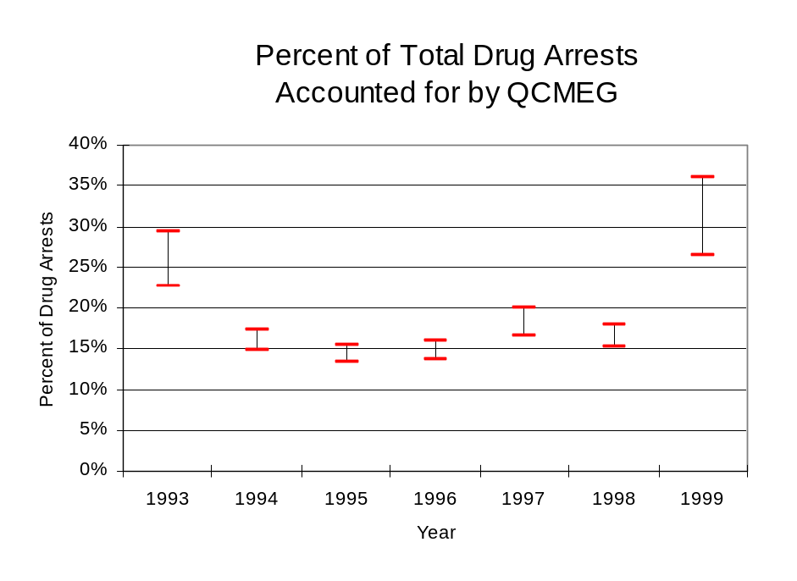
It is estimated that the proportion of all drug arrests made in the jurisdictions of participating agencies, and accounted for by QCMEG, was between 23 to 29 percent in 1993, and increased to between 26 to 36 percent in 1999. Between 1994 and 1998, the proportion of drug arrests made by QCMEG in jurisdictions covered by participating agencies represented a small proportion of all drug arrest made by participating agencies. However, this proportion raised dramatically in 1999 despite the fact that the officers assigned to QCMEG accounted for a small proportion of the total number of officers in participating agencies.
Source: ICJIA calculations using Illinois State Police and QCMEG data
Figure 9

The number of arrests for violations of Illinois’ Cannabis Control Act in Rock Island County totaled 469 in 1999, a 47 percent increase from the 318 arrests made for cannabis violations in 1993. Between 1993 and 1999, the proportion of all drug arrests accounted for by violations of the Cannabis Control Act in the region increased 9 percent, increasing from 64 percent to 69 percent. Agencies participating in QCMEG accounted for the largest portion (82 percent) of the total number of arrests for cannabis violations. QCMEG reported a total of 76 arrests for cannabis violations in 1999, 34 percent of the unit's drug arrests.

During the period analyzed, the cannabis arrest rate for the region covered by QCMEG increased 50 percent, from 212 arrests per 100,000 population in 1993 to 318 arrests per 100,000 population in 1999. The cannabis arrest rate in the participating agencies increased 89 percent, from 183 to 345 arrests per 100,000 population, while the arrest rate in the non-participating agencies decreased 49 percent from 367 to 186 arrests per 100,000 population. The cannabis arrest rate for QCMEG, increased 19 percent, from 52 to 62 arrests per 100,000 population (Figure 10). Thus, the arrest rate for violations of the Cannabis Control Act was higher in the area served by non-participating agencies between 1993 and 1995 and in 1997. However, between 1996 and 1999 (excluding 1997), the arrest rate was higher in areas served by participating agencies.

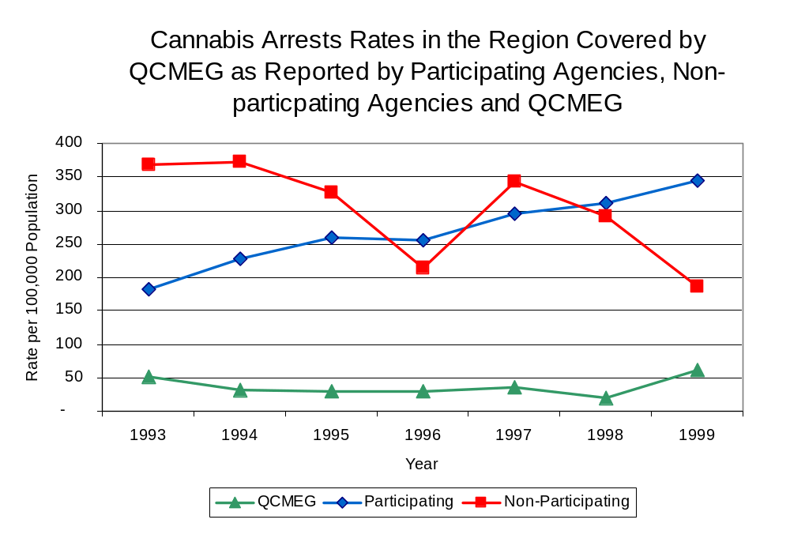
Source: ICJIA calculations using
Illinois State Police and QCMEG data
Figure 10
The data presented below represent the percent of total arrests for the violation of the Cannabis Control Act made by participating agencies that was accounted for by QCMEG. An upper and lower bound is shown in Figure 11, which accounts for whether or not the units numbers are counted as part of the UCR submissions made by participating departments (which is unknown at this point). The upper bound indicates the percentage of arrests if all of the QCMEG arrests are included in the local UCR submissions. The lower bound indicates the percentage if none of the QCMEG arrests are included in the local UCR submissions.

It is estimated that the proportion of all arrests for the violation of the Cannabis Control Act made in the jurisdictions of participating agencies, and accounted for by QCMEG, was between 22 to 29 percent in 1993, but decreased to between 15 to 18 percent in 1999. The data presented in Figure 11 suggest that although arrests for the violation of the Cannabis Control Act made by QCMEG in 1993 represented a moderate proportion of such arrests made in the jurisdictions of participating agencies, this proportion dropped in subsequent years.

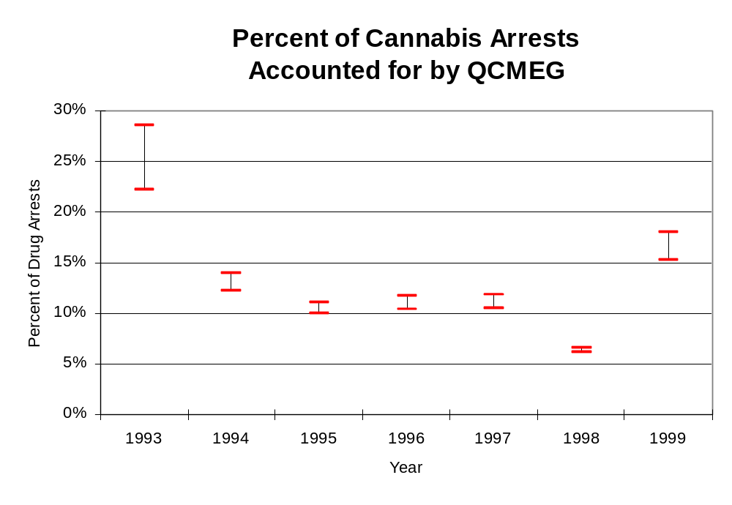
Figure 11
Source: ICJIA calculations using Illinois State Police and QCMEG data

In Rock Island County the number of arrests for violations of Illinois’ Controlled Substances Act increased 14 percent between 1993 and 1999, from 181 to 207. Between 1993 and 1999, the proportion of all drug arrests accounted for by violations of the Controlled Substances Act in the region decreased from 36 percent to 31 percent. In 1999, QCMEG reported 141 arrests for controlled substance violations, 66 percent of all drug arrests reported to the Authority by the unit.

Between 1993 and 1999, the arrest rate for controlled substances act violations for the region covered by QCMEG increased 16 percent, from 121 to 140 arrests per 100,000 population (Figure 12). The controlled substances arrest rate in the participating agencies increased 20 percent, from 131 to 157 arrests per 100,000 population, while the arrest rate in the non-participating agencies decreased 12 percent, from 68 to 59 arrests per 100,000 population. The controlled substances arrest rate for QCMEG almost tripled, from 40 to 118 arrests per 100,000 population (Figure 12). Thus, the arrest rate for violations of the Controlled Substances Act was higher in the participating agencies than the non-participating agencies.

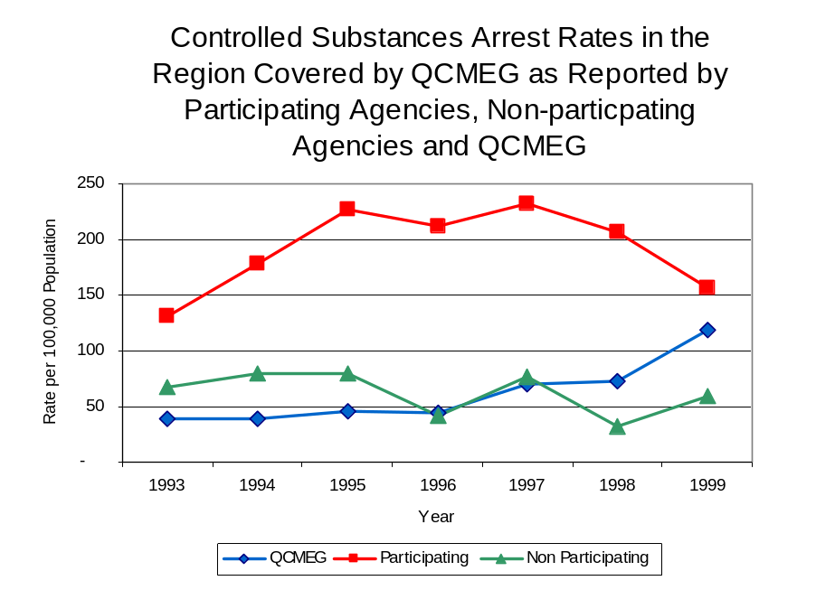
The data presented below represent the percent of total arrests for the violation of the Controlled Substances Act made by participating agencies that was accounted for by QCMEG. An upper and lower bound is shown in Figure 13, which accounts for whether or not the units numbers are counted as part of the UCR submissions made by participating departments (which is unknown at this point). The upper bound indicates the percentage of arrests if all of the QCMEG arrests are included in the local UCR submissions. The lower bound indicates the percentage if none of the QCMEG arrests are included in the local UCR submissions.
Figure 12
Source: ICJIA calculations using Illinois State Police and QCMEG data

It is estimated that the proportion of all arrests for the violation of the Controlled Substances Act made in the jurisdictions of participating agencies, and accounted for by QCMEG, was between 23 to 30 percent in 1993, and increased dramatically to between 43 to 76 percent in 1999. Unlike the arrests made by QCMEG for the violation of the Cannabis Control Act, arrests made by QCMEG for the violation of the Controlled Substances Act represented a large proportion of all the arrests made for similar offenses in the region covered by QCMEG despite having only a small proportion of total officers working in the region. When examining the three figures together (Figure 9, 11 and 13), the data suggest that QCMEG focused on arresting individuals violating the Controlled Substances Act, most of which are felony offenses.

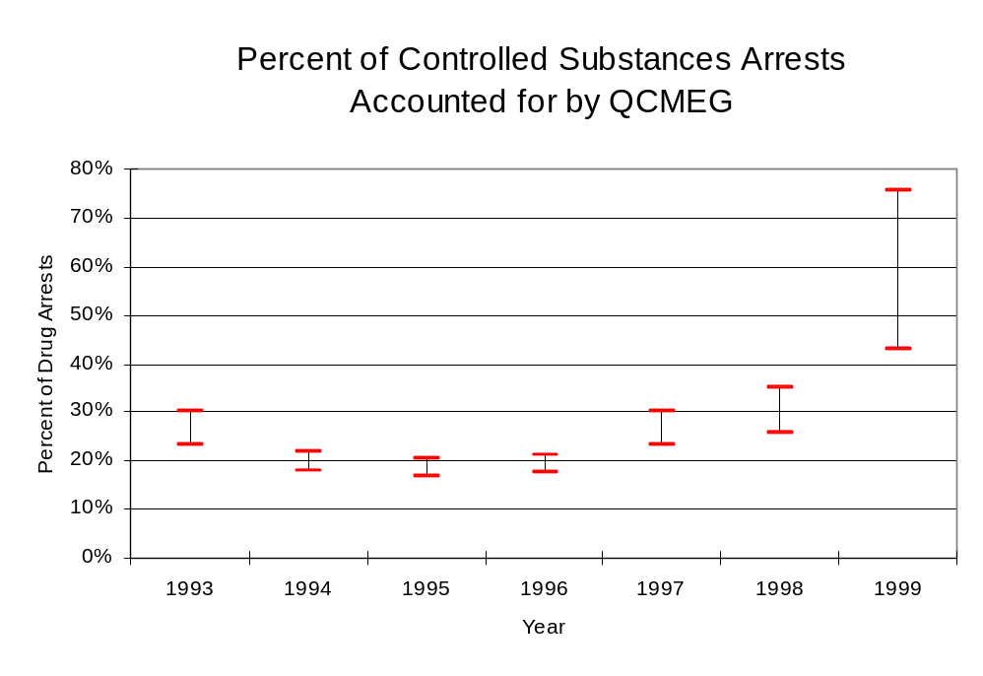
The majority of all drug arrests reported by QCMEG are for delivery. Between 1993 and 1999, the number of drug delivery arrests made by QCMEG increased 91 percent, from 95 to 185. Arrests for drug delivery accounted for 81 percent of all drug arrests made by QCMEG between 1993 and 1999. When cannabis and controlled substance arrests were examined separately, arrests for delivery of controlled substances accounted for 86 percent of the total number of arrests made for violations of the Controlled Substance Act, whereas, arrests for the delivery of cannabis accounted for 73 percent of all arrests for violations of the Cannabis Act. Thus, while the number of arrests increased between 1993 and 1999, the proportion of arrests for delivery of cannabis decreased and the proportion of arrests for delivery of a controlled substance remained relatively stable.
Figure 13
Source: ICJIA calculations using Illinois State Police and QCMEG data
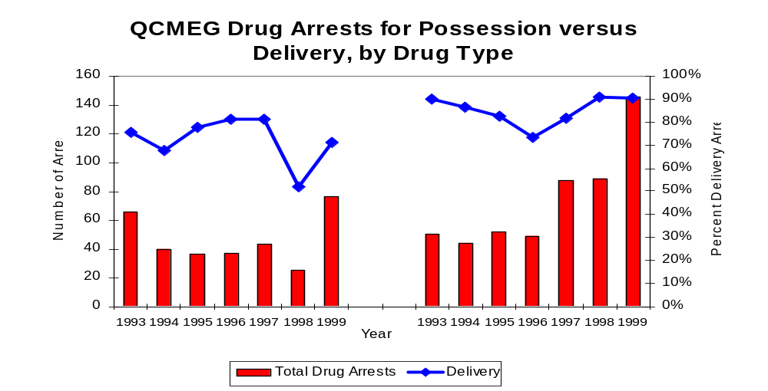
Figure 14
Source: ICJIA calculations using QCMEG data
Cannabis Control Act
Controlled Substances Act

Cannabis Control Act
IV. Trends in Drug Seizures

Drugs seized by law enforcement agencies are another indicator of the extent and nature of illegal drug trade in a jurisdiction. When illegal drugs are seized by law enforcement agencies, all or a portion of the total amount seized is submitted to a crime lab for analysis. Most agencies submit drugs to one of the Illinois State Police crime labs. These labs record the quantity of drugs submitted from each county. This section discusses trends in the quantities of illegal drugs seized and submitted to the Illinois State Police from local law enforcement agencies in Rock Island County as well as the quantities of drugs seized by QCMEG. It is important to note, however, that while QCMEG data report the total quantities of drugs actually seized, local agency data only represent the quantities of seized drugs that are submitted to the Illinois State Police for analysis. County-level cannabis, cocaine and methamphetamine seizure rates for Illinois' 102 counties are provided in maps located in the Appendix of this report.

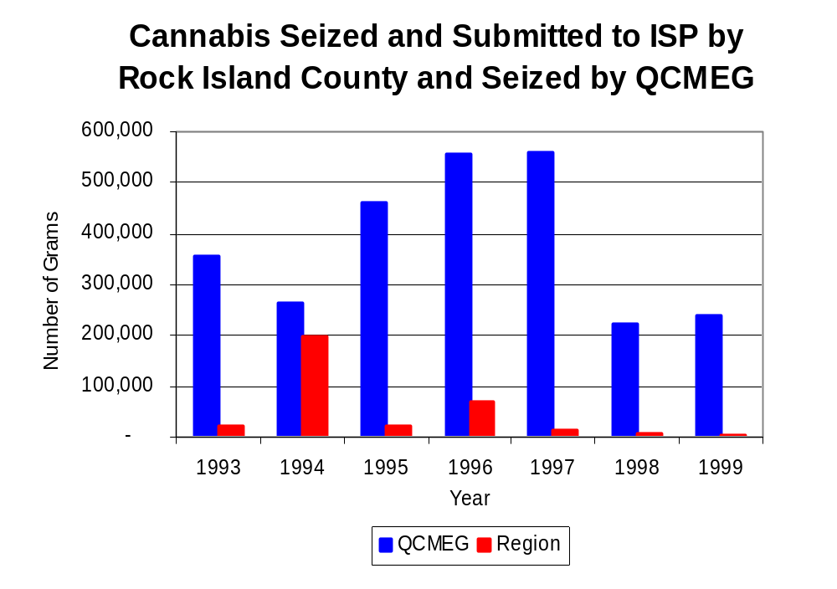
As in most Illinois jurisdictions, cannabis accounts for the majority of illegal drugs seized in the region covered by QCMEG. The quantity of cannabis seized and submitted by law enforcement agencies in Rock Island County decreased 89 percent, from 20,991 grams in 1993 to 2,401 grams in 1999, with 197,748 grams being seized in 1994, the largest amount seized during the period analyzed. The quantity of cannabis seized by QCMEG also decreased 33 percent between 1993 and 1999, from 356,249 grams to 240,033 grams despite jumping to almost 600,000 grams seized in 1996 and 1997 (Figure 15). In 1999, QCMEG's cannabis seizure rate of 196,086 grams per 100,000 population 84 percent more than the statewide cannabis seizure rate of 31,533 grams per 100,000 population, but significantly greater than the seizure rate of 1,626 grams per 100,000 population in the region covered by QCMEG (Map 2).
Figure 15
Source: Illinois State Police and QCMEG

Between 1993 and 1999, a combination of crack and powder cocaine has accounted for an increasing proportion of drugs seized in the region covered by QCMEG. The quantity of cocaine seized and submitted by law enforcement agencies in Rock Island County decreased 66 percent, from 3,219 grams in 1993 to 1,095 grams in 1999. Between 1993 and 1999, the quantity of cocaine seized by QCMEG decreased 78 percent, from 9,768 grams to 2,121 grams.

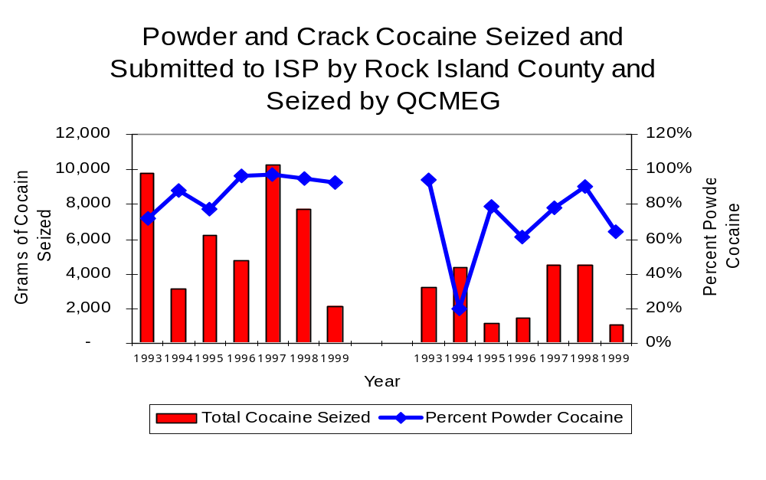
The proportion of all cocaine seized accounted for by powder cocaine in the region covered by QCMEG varied between 1993 and 1999, with the proportion of all cocaine seized accounted for by powder cocaine dropping to 20 percent in 1994. For QCMEG, although powder cocaine accounted for the largest proportion of total cocaine seizures in every year examined, the proportion was only 72 percent of the total cocaine seized by QCMEG in 1993 (Figure 16). In 1999, QCMEG's cocaine seizure rate of 1,733 grams per 100,000 population double the cocaine seizure rate of 742 grams per 100,000 population in the region covered by QCMEG, but 89 percent less than the statewide cocaine seizure rate of 15,735 grams per 100,000 population (Map 3).
Figure 16
Source: Illinois State Police and QCMEG
QCMEG
Region
QCMEG
Region

The total quantity of illegal drugs seized and submitted by law enforcement agencies in Rock Island County decreased between 1993 and 1999, from 24,685 grams to 3,669 grams. Also, the total quantity of illegal drugs seized by QCMEG decreased, from 447,860 grams in 1993 to 254,247 grams in 1999.

During the period, methamphetamine seizures accounted for a relatively small proportion of total drugs seized by QCMEG and the region covered by QCMEG. Between 1993 and 1999, the quantity of methamphetamine seized by law enforcement agencies in the region covered by QCMEG decreased 64 percent, from 120 grams to 43 grams. Conversely, the quantity of methamphetamine seized by QCMEG increased. While there were no reported methamphetamine seizures by QCMEG in 1993 and 1994, the quantity seized increased from less than two grams in 1994 to 329 grams in 1999 (with 1,322 grams seized in 1997). In 1999, QCMEG had a methamphetamine seizure rate of 269 grams per 100,000 population, nearly ten times the rate of 29 grams per 100,000 population in the region covered by QCMEG and nearly triple the statewide seizure rate of 98 grams per 100,000 population (Map 4).
V. Trends in Prosecutions for Drug Offenses and All Felonies

Although Illinois has one of the best court reporting systems in the country, the Administrative Office of the Illinois Court only collects information regarding the aggregate number of court filings. Currently, there are no statewide data available on court filings by offense type. The Administrative Office of the Illinois Courts reports data on felony criminal court cases. After screening a case and deciding it warrants further action, the state’s attorney must file formal charges in court. Felony cases can be punished by a probation term up to four years and incarceration for more than one year.

Between 1989 and 1999, the number of felony filings in the region covered by QCMEG increased 16 percent, from 943 to 1,096 (Figure 17).

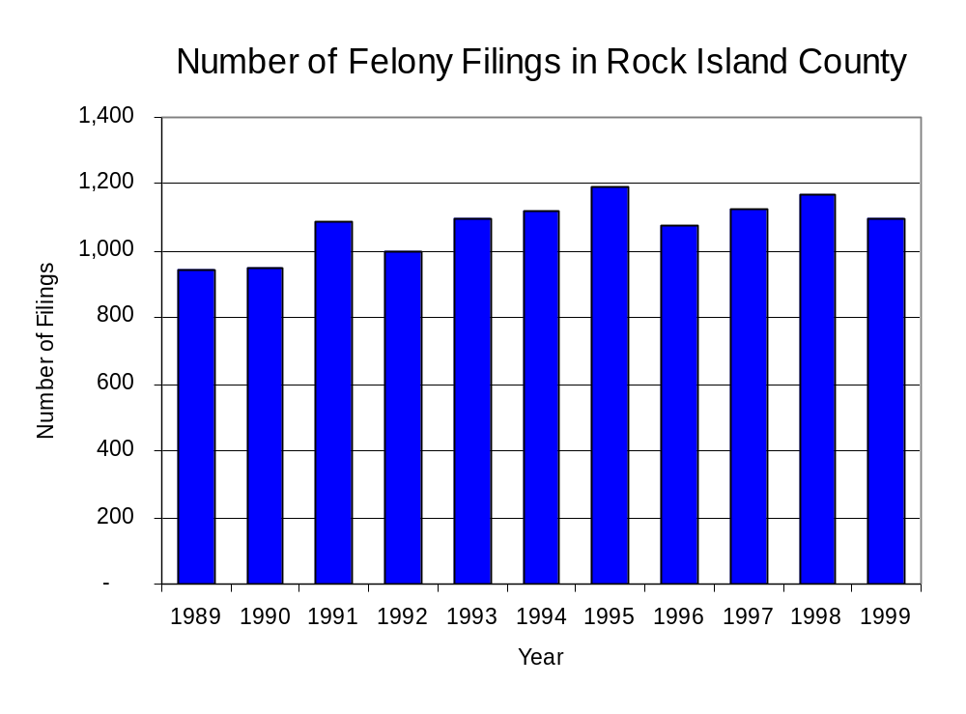
Figure 17
Source: Administrative Office of the Illinois Courts

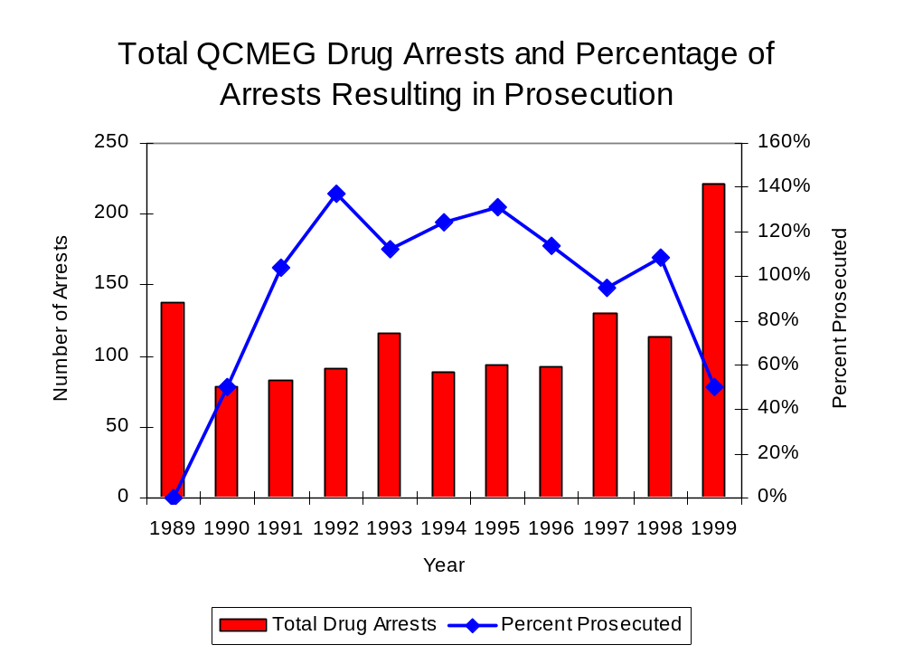
Between 1989 and 1999, there were a total of 1,077 drug prosecutions initiated as a result of QCMEG arrests in Rock Island County. During this time, the number of QCMEG drug arrests increased 61 percent, from 137 arrests in 1989 to 221 arrests in 1999 (Figure 18). Between 1989 and 1999, approximately 86 percent of drug arrests by QCMEG resulted in prosecution. No prosecutions were reported in 1989. Sixty-three percent of QCMEG drug offender prosecutions during this period were for violations of the Controlled Substance Act. In some years, the proportion of arrests resulting in a prosecution exceeded 100 percent. This is due to some slight differences in the timing of an arrest and the filings of charges. It could also be due to charges, rather than defendants, being reported by the unit. Also, some offenders have charges filed, and a subsequent warrant issued, without an arrest taking place.
Figure 18
Source: QCMEG

Between 1989 and 1999, 91 percent (983) of the 1,077 drug offenders who were prosecuted as a result of QCMEG activity were convicted. Convictions for controlled substances accounted for 67 percent of all QCMEG initiated convictions during the period analyzed.

VI. Trends in Percent of Convicted Drug Offenders Sentenced to Prison

Anyone convicted of a felony in Illinois can be sentenced either to prison or probation, or receive conditional discharge. A number of factors influence the type and length of sentence imposed on convicted felons, including the severity of the crime, the offender’s criminal and social history, safety of the community and legislation affecting certain types of offenses. For some types of convictions, a sentence to prison is required by state statute.

Between 1989 and 1999, the number of offenders convicted of a felony and sentenced in the region covered by QCMEG increased 59 percent, from 509 to 808. Although the number of convicted felons sentenced to the Illinois Department of Corrections (IDOC) increased 79 percent between 1989 and 1999, from 156 to 279, the proportion of felons sentenced to IDOC remained relatively stable during the same period. In 1999, 488 probation sentences were imposed on convicted felons, a 39 percent increase from the 351 probation sentences in 1989 (Figure 19). However, the proportion of felons sentenced to probation decreased from 69 percent in 1989 to 60 percent in 1999, largely due to the increase in jail sentences.
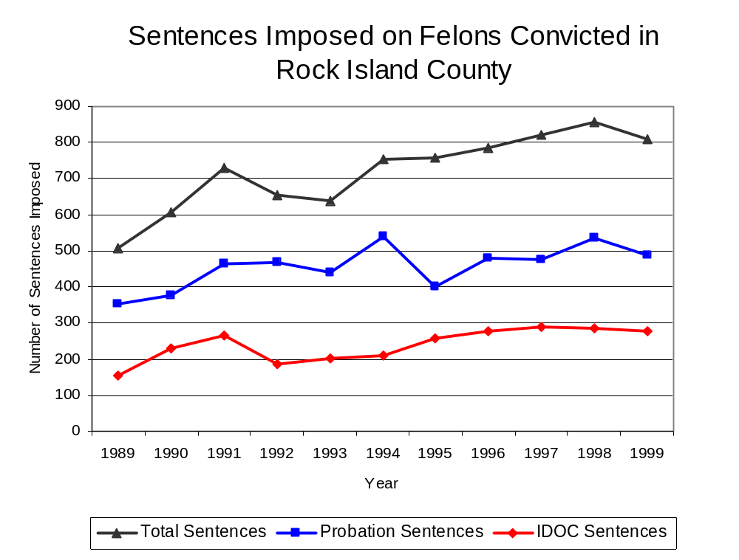
Figure 19
Source: Administrative Office of the Illinois Courts

Between 1990 and 1999, the number of QCMEG drug offenders convicted and sentenced increased from 33 to 72, with 128 drug offenders convicted and sentenced in 1995, an all time high for the period examined. During the period analyzed, the number of convicted QCMEG drug offenders sentenced to probation increased from 15 in 1990 to 24 in 1999, although in 1995, the number of convicted QCMEG drug offenders sentenced to probation reached a high of 65. Similarly, the number of convicted QCMEG drug offenders sentenced to jail decreased slightly while the number of drug offenders sentenced to prison increased from 12 to 44 (Figure 20). In 1999, among those QCMEG drug offenders convicted and sentenced, prison sentences accounted for the largest proportion (61 percent), followed by probation sentences (33 percent) and jail sentences (6 percent).
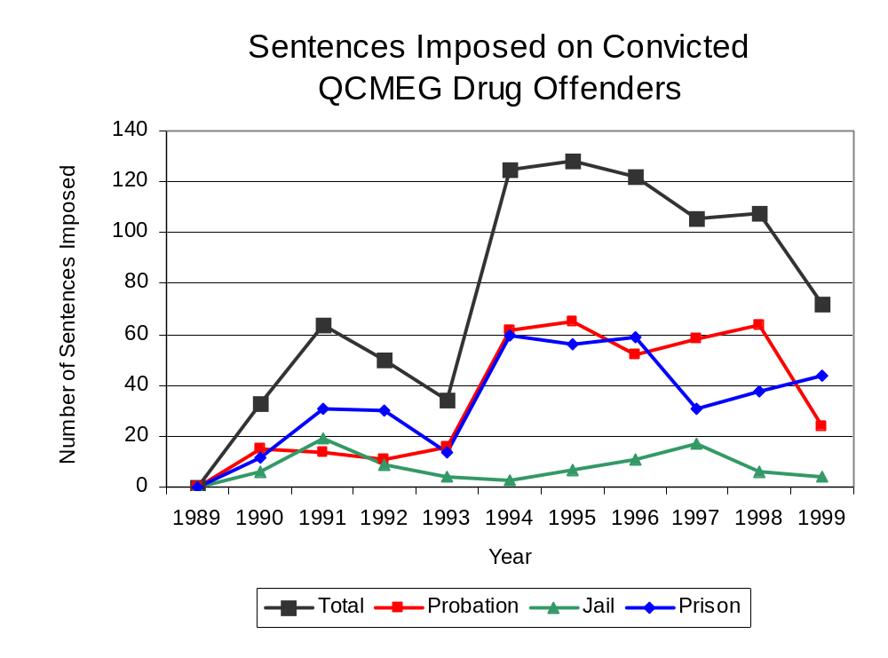
Figure 20
Source: QCMEG

Between state fiscal years 1989 and 1999, the number of new court commitments to IDOC’s Adult Division for drug offenses from the region covered by QCMEG more than tripled, from 20 to 65. The number of drug offender admissions by QCMEG also increased from three to 38 between 1991 and 1999 (Figure 21). Between 1989 and 1999, drug offender admissions to IDOC by QCMEG accounted for 50 percent of all drug admissions in Rock Island County.
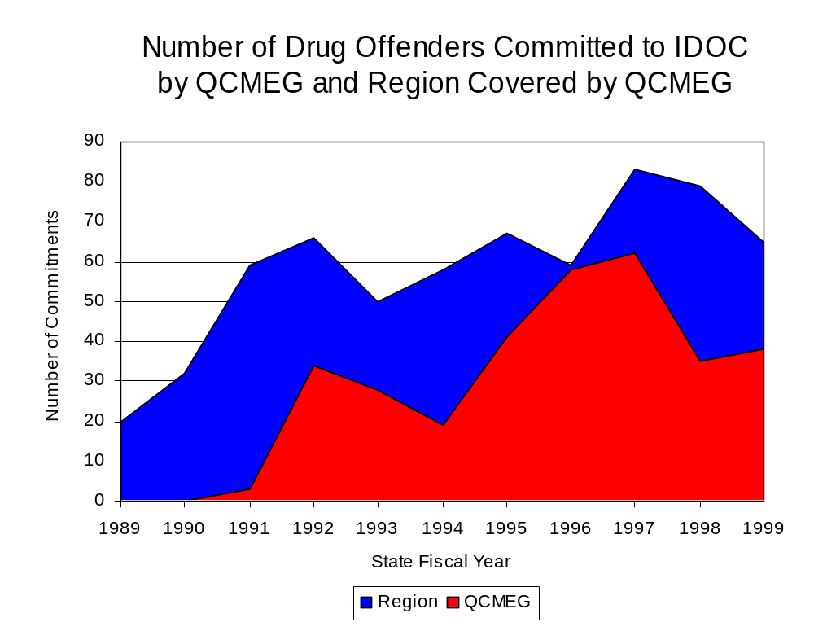
Figure 21
Source: Illinois Department of Corrections and QCMEG

During the period analyzed, drug offenders accounted for an increasing proportion of adults convicted and sentenced to prison from Rock Island County. In 1989, drug offenses accounted for 14 percent of all commitments to IDOC, compared to 25 percent in 1999 (Figure 22).
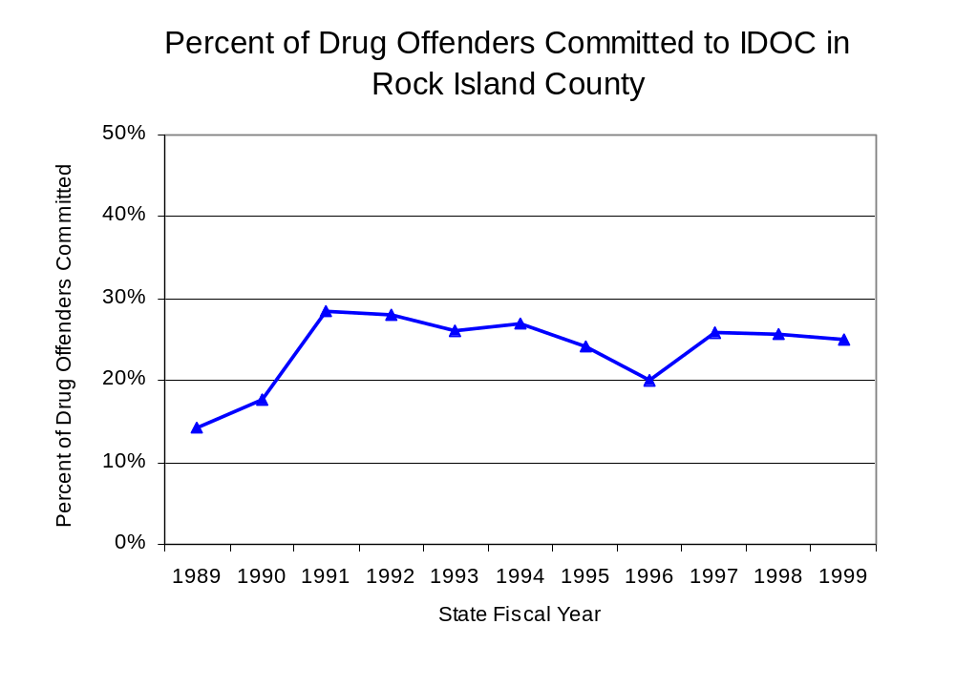
Figure 22
Source: Illinois Department of Corrections

Penalties for drug offenses were also examined between 1993 and 1999. Class 4 felonies accounted for the largest proportion (32 percent) of sentences to IDOC for drug offenses, followed by Class 1 felonies (25 percent), Class 2 felonies (19 percent), Class X felonies (15 percent) and Class 3 felonies (10 percent). Between 1993 and 1999, the number of offenders held in IDOC for Class 1, 2, and 4 drug felonies increased, while the number of Class 3 and X felonies decreased. However, in 1997, the number of Class X felonies jumped to 36. (Figure 23).

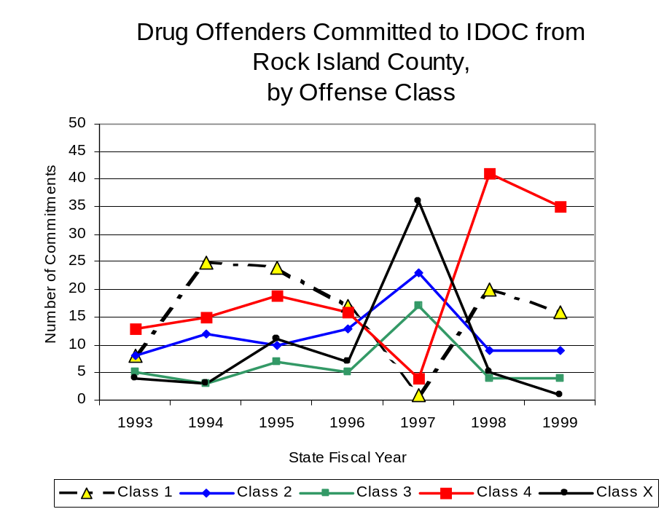
Along with the increase in most of the felony sentences to IDOC, the mean sentence length increased across all offense classes. Between 1993 and 1999, the mean sentence length for Class 3 felonies experienced the largest increase during the period analyzed, increasing from 3.2 to 5.7 years. The mean sentence lengths for Class 1 felonies increased from 4.9 to 7.0 years, while the mean sentence length for Class X felonies increased from 6.7 to 9.0 years and the mean sentence length for Class 2 felonies increased from 3.3 4.2 years. Despite experiencing the largest increase of felony sentences, Class 4 felonies accounted for the smallest increase in mean sentence length, increasing 25 percent, from 2.6 to 3.2 years.
Figure 23
Source: Illinois Department of Corrections

Based on data collected from the 2000 Illinois Adult Probation Outcome Study, almost one-third (30.3 percent) of all adults discharged from probation in Rock Island County during the study period (November 2000) were convicted of drug-law violations. Of these drug-law violators discharged from probation in the county, almost all (95.7 percent) had been convicted of a felony drug offense. In addition, more than three-quarters (82.6 percent) of these drug-law violators were ordered to participate in some form of treatment, and each was ordered to pay, on average, $1,701 in the form of supervision fees, court costs and fines.

VII. Trends in Drug Treatment Admissions in QCMEG Region by Drug Type

In addition to considering indicators of the extent and nature of drug abuse as reported through the criminal justice system (for example, arrests and prison sentences), there are indicators of substance abuse available from other Illinois social service agencies. Overseeing and supporting treatment for substance users, whether they are referred from the criminal justice system or elsewhere, is the responsibility of the Illinois Department of Human Services’ Office of Alcoholism and Substance Abuse (OASA). It is important to note, however, that while OASA data represent the majority of the overall demand for substance abuse treatment in the state, some private programs provide treatment services to a smaller but significant number of clients who may not be included in the state’s reporting system.

In state fiscal year 1999, OASA reported 2,418 admissions for alcohol or drug abuse treatment from Rock Island County, a 31 percent decrease from the 3,497 admissions in 1989 (Figure 24). Among the 2,418 admissions to substance abuse treatment in state fiscal year 1999, 57 percent (1,389) reported alcohol as their primary substance of abuse, while abuse of illicit substances accounted for 39 percent. Three percent reported no primary substance of abuse.

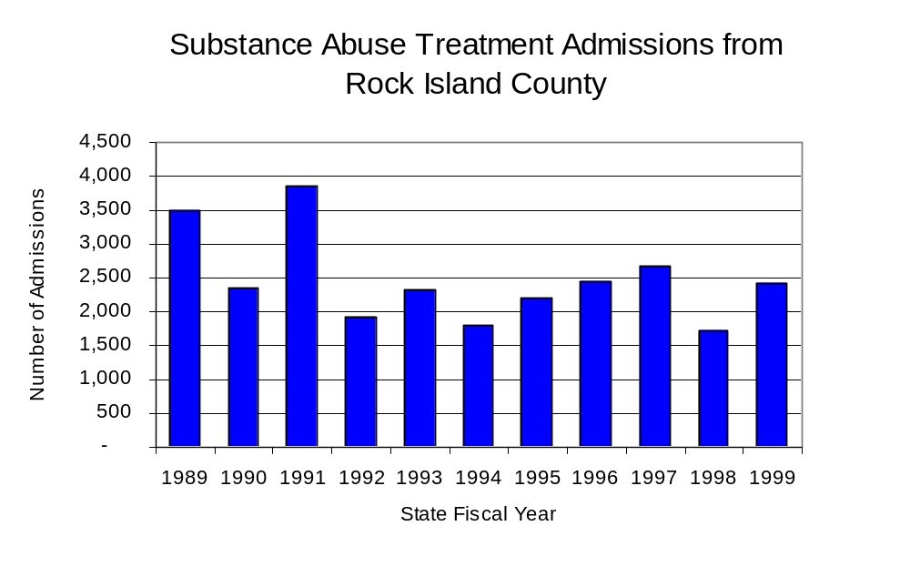
Figure 24
Source: Illinois Department of Human Services’
Office of Alcoholism and Substance Abuse
While drug treatment admissions can be considered a measure of the demand placed on a specific component of the human services system within Illinois, the extent and nature of drug treatment admissions could also be indicative of the substance abuse problem within a particular region. In some respects, the characteristics of those admitted to drug treatment can be considered a profile of the most serious drug abusers in the community, since admission to treatment requires a documented, formal assessment of a drug problem and a level of substance abuse warranting treatment. By comparing the types of drugs of abuse reported by those admitted to substance abuse treatment with the types of drugs involved in law enforcement agency arrests, one can get a sense of the degree to which arrests reflect the drugs which are most problematic within a community.

In the following analyses, the percent of arrests accounted for by drugs classified under Illinois’ Controlled Substances Act (primarily cocaine, heroin, and methamphetamine) versus the Cannabis Control Act (marijuana) across the participating agencies combined, non-participating agencies combined and QCMEG are compared to the proportion of drug treatment admissions accounted for by these groups of substances. From these comparisons, a number of general conclusions can be made. First, the proportion of arrests made by QCMEG accounted for by drugs other than marijuana (Controlled Substances Act offenses) was fairly close to the proportion of drug treatment admissions from the covered region accounted for by these substances. On the other hand, the majority of arrests by local police departments (including those participating in QCMEG and non-participating agencies) were for cannabis offenses. Thus, while local arrests may reflect the most widely available and used drug in the region, they tend not to involve the substances considered to be most serious (i.e., felony versus misdemeanor) nor the substances individuals were seeking and receiving treatment for (Figure 25).

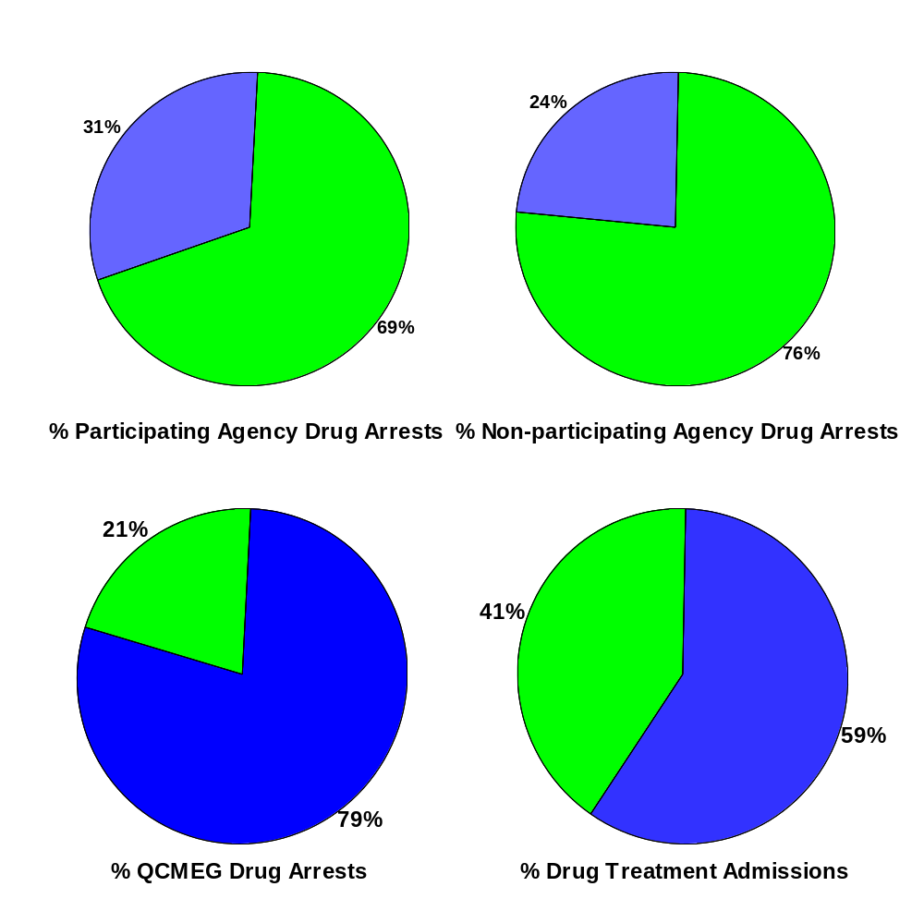
CannabisControlled Substances
Comparison of Drug Arrests by QCMEG and Participating and Non-participating Agencies vs. Drug Abuse Treatment Admissions in
Rock Island County, 1999

Source: Illinois Department of Human Service's Office of Alcoholism and Substance Abuse and QCMEG
Figure 25
79%
% QCMEG Drug Arrests
59%
% Drug Treatment Admissions
VIII. Trends in Drug Exposed Births

Illinois continues to experience the effects of prenatal substance abuse. In Illinois, if a baby is born and thought to have been exposed to illegal substances or alcohol, either through observation by physicians or toxicology tests, the case is reported to the Illinois Department of Children and Family Services. These cases are then investigated by DCFS to verify the child’s prenatal exposure to either alcohol or illegal substances. Between state fiscal years 1989 and 1999, nearly one-half (50) of Illinois’ 102 counties reported at least one case of a substance-affected infant.

Between state fiscal years 1989 and 1999, the number of drug-exposed infant cases reported in the region covered by QCMEG increased from 7 to 13 reported cases, although in 1997, the number of cases reported reached 30 cases. Between state fiscal years 1989 and 1999, 160 cases, or 84 percent of all cases reported, were verified as involving prenatal drug use by a DCFS investigation. Mirroring the trend of reported cases, verified cases of drug-exposed infants in the QCMEG region also increased between 1989 and 1999 (Figure 26).

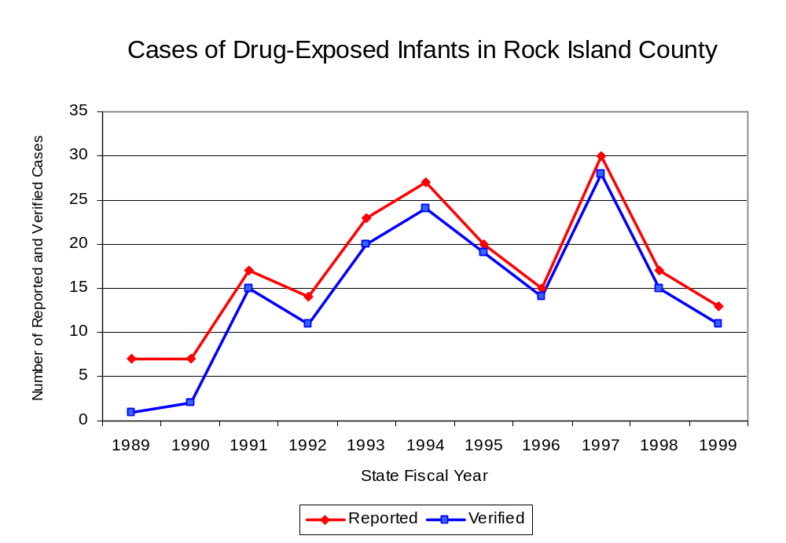
Source: Department of Children and Family Services
Figure 26

IX. Summary of Drug Situation

Although the distribution of illegal drugs is difficult to measure precisely, data obtained from criminal justice sources can be helpful in estimating drug availability. Information from a recent survey of Illinois drug enforcement units, as well as the most up-to-date data available on drug price, are presented as indicators of the drug supply in Illinois.

In 1995, 1996 and 1998, the Authority conducted a survey of each MEG and task force in Illinois to gauge the perceived availability of drugs in the areas they cover. Questions were asked concerning the availability of specific drugs, and results were analyzed by region of the state. MEGs and task forces are classified as being either urban, rural or mixed urban/rural based upon the classification of the county(s) that each unit covers, and, for purposes of this report, are compared to the average of similar units.

According to QCMEG survey responses, cannabis, cocaine and crack continued to be the most visible drugs on the street and were all reported to be “readily available” across all regions analyzed. Methamphetamine was reported as moderately available across Illinois but available to a somewhat lesser degree in the region covered by all MEGs and task forces in mixed urban/rural regions. The perceived availability of cannabis, cocaine, crack and PCP, tended to be similar across Illinois, other mixed urban/rural regions, and the region covered by QCMEG (Figure 27).
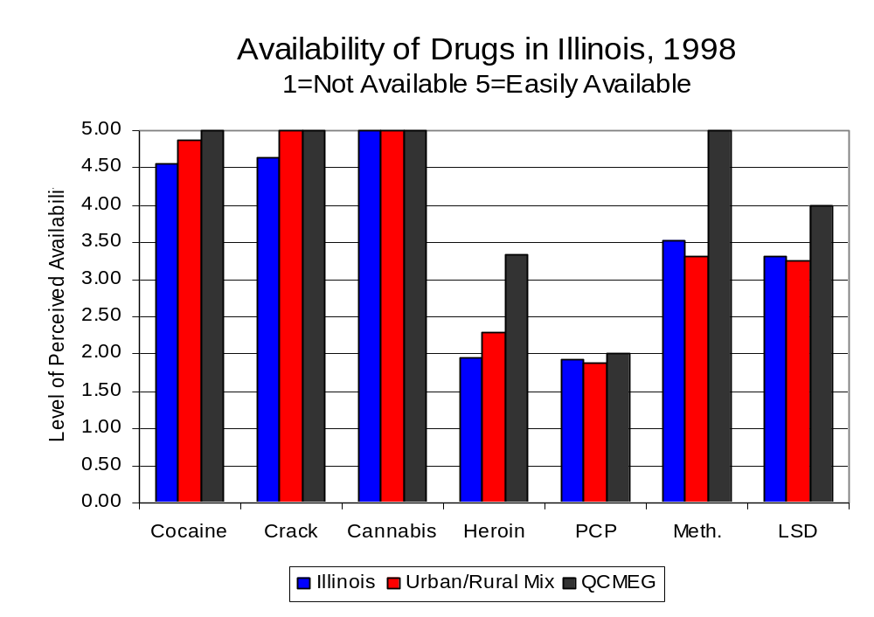
Figure 27
Source: Authority Survey of Illinois MEGs and task forces
Another market indicator that can be used to assess availability is drug price. Lower prices tend to suggest a sufficient supply to meet demand, while increasing prices indicate decreased availability.

Based on a statewide survey of MEG and task force units, the average price of cocaine, crack and methamphetamine appear to be relatively stable across all regions surveyed in 1998, while prices for PCP and heroin appear to vary somewhat across Illinois. The average price of cocaine in the region covered by QCMEG remained the same between 1996 and 1998, while it increased across Illinois and other mixed urban/rural regions. However, for the region covered by QCMEG the price of heroin decreased dramatically from $300 in 1996 to $100 in 1998, unlike the other mixed urban/rural regions where the price increased. The 1998 average price of cocaine reported by QCMEG was $100 per gram, compared to $98 per gram across Illinois and $103 per gram reported by all MEGs and task forces in other mixed urban/rural regions (Figure 28). On the other hand, the average price of heroin in the region covered by QCMEG was reported as $100 per gram, lower than the price of $165 per gram across Illinois and the price of $214 per gram reported by other task forces in mixed urban/rural regions. In 1998, the average price of cannabis was reported was approximately $4 per gram in the QCMEG region, $7 per gram in mixed urban/rural regions and $8 per gram across Illinois.

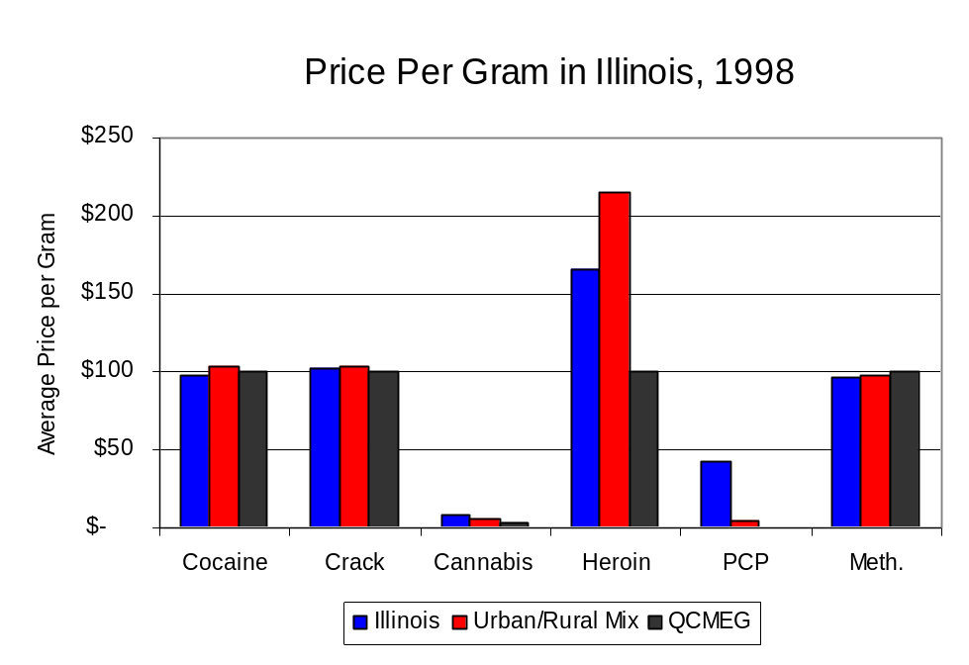
Figure 28
Source: Authority Survey of Illinois MEGs and task forces

X. Appendices
1999 Percent of Illinois'
County-level Population Covered by an Authority-funded Multi-jurisdictional Enforcement Group or Task Force
Map 1
* Shaded counties indicate that at least one law enforcement agency within the county participates in a MEG or task force
Percent of County Population Covered by MEG or Task Force

1999 Illinois
Cannabis
Seizure Rates, by County
Map 2
Cannabis Seizure Rate
(rate per 100,000 population)
1999 Illinois
Cocaine
Seizure Rates, by County
Map 3
Cocaine Seizure Rate
(rate per 100,000 population)
1999 Illinois Methamphetamine
Seizure Rates, by County
Map 4
Methamphetamine Seizure Rate
(rate per 100,000 population)

Bibliography

Administrative Office of the Illinois Courts, Annual Report to the Supreme Court of Illinois.
1989 through 1999 reports, Springfield, Illinois.

Administrative Office of the Illinois Courts’ Probation Division, Statewide Probation Data
Report. 1989 through 1999 reports, Springfield, Illinois.

Illinois Department of Human Services’ Office of Alcoholism and Substance Abuse. Data
provided for state fiscal years 1989 through 1999, Springfield, Illinois.

Illinois Department of Children and Family Services, Child Abuse/Neglect Statistics Report,
1989 through 1999 reports, Springfield, Illinois.

Illinois Department of Corrections. Data provided for fiscal years 1989 through 1999,
Springfield, Illinois.

Illinois State Police, Crime in Illinois. 1993 through 1999 reports, Springfield, Illinois.

Illinois State Police, Drug Statistics Report. Monthly reports, January 1989 through
December 1999, Springfield, Illinois.

Quad-Cities Metropolitan Enforcement Group. Monthly reports, January 1989 through December
1999, Moline, Illinois.

U.S. Bureau of the Census.


George H. Ryan, Governor
Peter B. Bensinger, Chairman
Candice M. Kane, Executive Director

